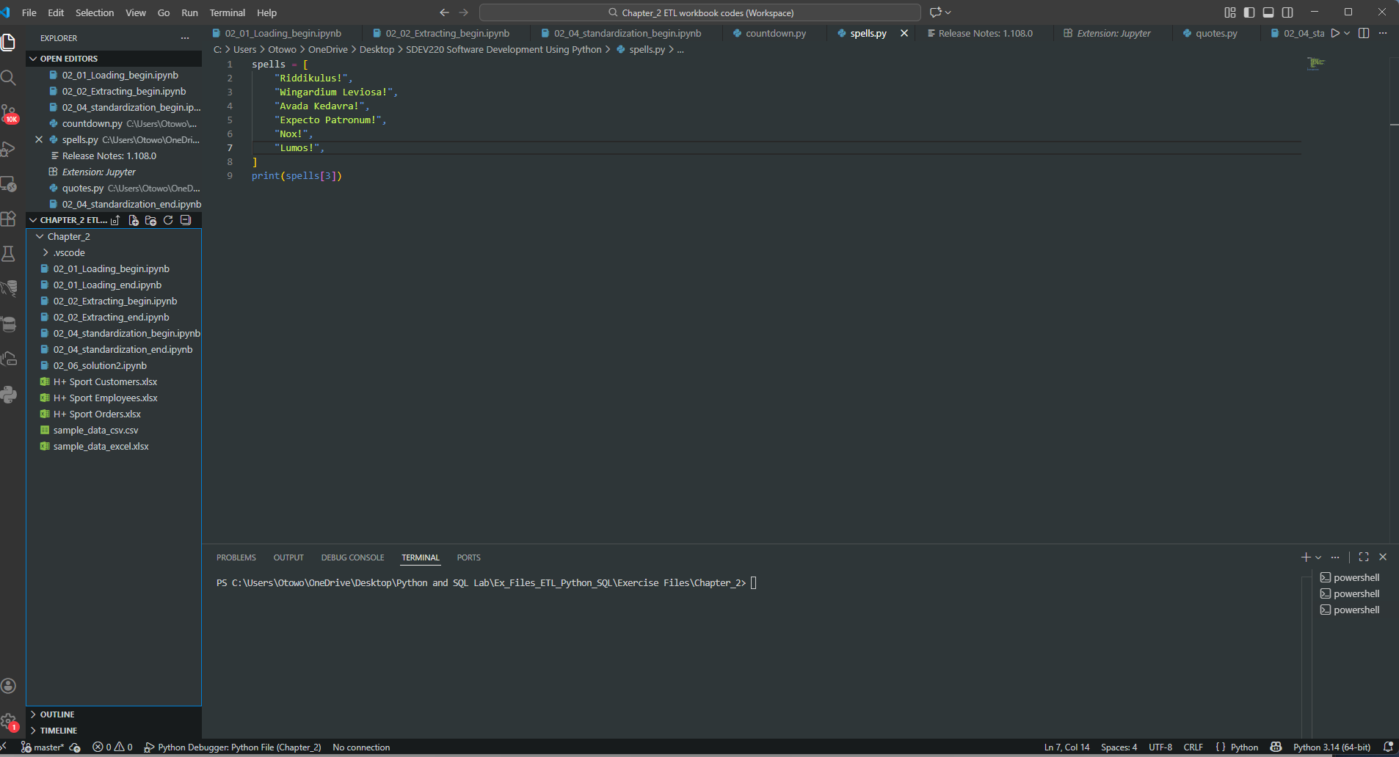
  - Screenshot of Visual Studio Code program.

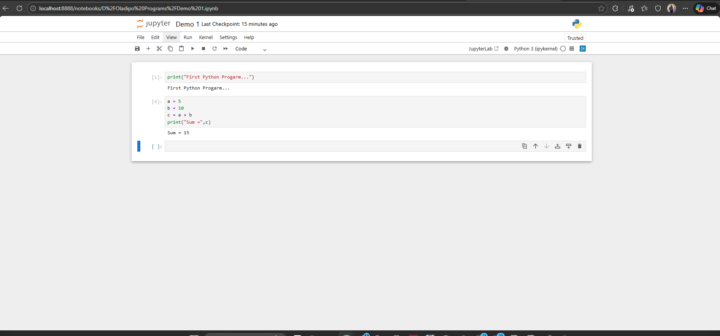
1.2 Screenshot of Jupyter Notebook program.

